**A Dissertation Report on**

**Trading Strategies in Cryto Currency Market**

**Daniel Sapkota**

**ID: 16401960**

**BSc Computing**

**Supervisor: Himalaya Kakshyapati**

**NAMI College**

**University of Northampton**

**Jorpati, Kathmandu, Nepal**

Acknowledgement

Table of Contents

1. Introduction 3

1.1. Aims and Objectives 3

1.2. Hypothesis 3

2. Background 3

3. Literature Review 4

3.1. Trading Strategies 4

3.2. Machine Learning 4

3.3. Algorithmic Trading 4

3.4. Backtest 4

4. Analysis and Project Specification 4

5. Design 4

5.1. Program Structure 4

6. Implementation 4

6.1. Program Structure 4

6.2. Data Collection 4

6.3. 4

7. Testing 4

7.1. Unit Testing 4

7.2. Quality Testing 4

7.3. Functionality Testing 4

7.4. Backtest 4

8. Conclusion 4

8.1. Summary 4

8.2. Further Work 4

9. Further Work 4

10. Appendix 1 – Use of algorithms in Trading 5

11. Appendix 2 – Cryptocurrency Market 5

12. Appendix 1 - Gantt Chart 6

13. Appendix 2 – Further Information 8

14. Appendix 3 – Meeting Logs 8

15. Appendix 3 – Presentation Slides 10

# Introduction

## Aims and Objectives

## Hypothesis

# Background

# Literature Review

## Trading Strategies

## Machine Learning

## Algorithmic Trading

## Backtest

# Requirement Analysis and Project Specification

It is a process of collecting and interpreting facts, identifying the problems, and decomposition of a system into its components.

Constrains

**analysis** functions may include budget tracking and financial forecasting, **project**evaluation and monitoring, maintaining compliance with corporate and public regulations, and performing any data **analysis** relevant to **project** tasks

It contains all goals, functionality, and details required for a development team to fulfill the vision of the client.

# Design

## Program Structure

## Backtesting Engine

## Prediction Model

# Implementation

## Program Structure

## Data Collection

## 

# Testing

## Unit Testing

## Quality Testing

## Functionality Testing

## Backtest

# Conclusion

## Result

## Summary

## Further Work

# Further Work

First the learning algorithm must be changed, and new data should be added from chart history to get a better result. Technical analysis data also must be calculated. Then predictions should be done on altcoins too. Then the collected social media, news and other public data should be used to add them as features. Then changes should be made in the model depending on the output. Finally, after a satisfactory model is made (which does good on test) – risk calculations should be done to make changes.

# Appendix 1 – Use of algorithms in Trading

# Appendix 2 – Cryptocurrency Market

# Appendix 1 - Gantt Chart

|  |  |  |  |  |  |  |  |  |  |  |  |  |
| --- | --- | --- | --- | --- | --- | --- | --- | --- | --- | --- | --- | --- |
| **Task** | **November** | | **December** | | **January** | | **February** | | **March** | | **April** | |
| Learn More About Machine Learning. |  |  |  |  |  |  |  |  |  |  |  |  |
| Start Logging Data from Exchanges |  |  |  |  |  |  |  |  |  |  |  |  |
| Read Papers and Books on Machine Learning Models |  |  |  |  |  |  |  |  |  |  |  |  |
| Start working on creating and testing Features |  |  |  |  |  |  |  |  |  |  |  |  |
| Grab the Reddit and Twitter Social Media Data |  |  |  |  |  |  |  |  |  |  |  |  |
| Create and test features from old price data, correlations and Technical Data |  |  |  |  |  |  |  |  |  |  |  |  |
| Analyze the sentiment from twitter, reddit and google trends to create features based on them to add to the model |  |  |  |  |  |  |  |  |  |  |  |  |
| Test the Hyper Parameters |  |  |  |  |  |  |  |  |  |  |  |  |
| Finalize the Model and create the final script. Create forecasts and analyze risks |  |  |  |  |  |  |  |  |  |  |  |  |
| Fixing Bugs and Making the Thesis Better |  |  |  |  |  |  |  |  |  |  |  |  |

# Appendix 2 – Further Information

# Appendix 3 – Meeting Logs

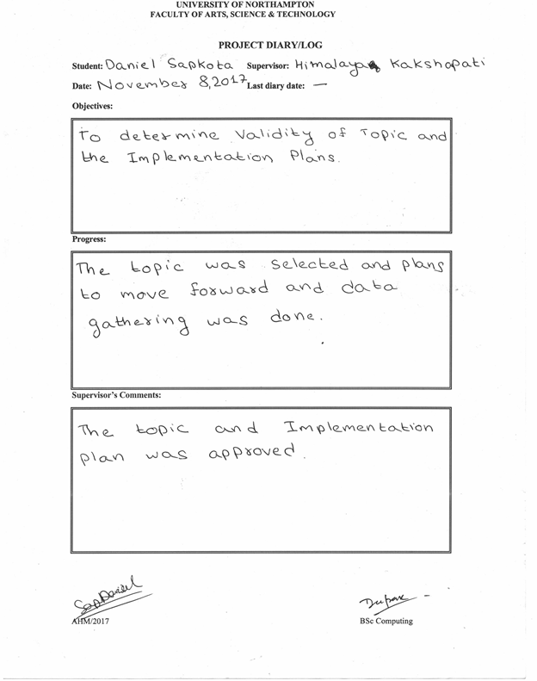

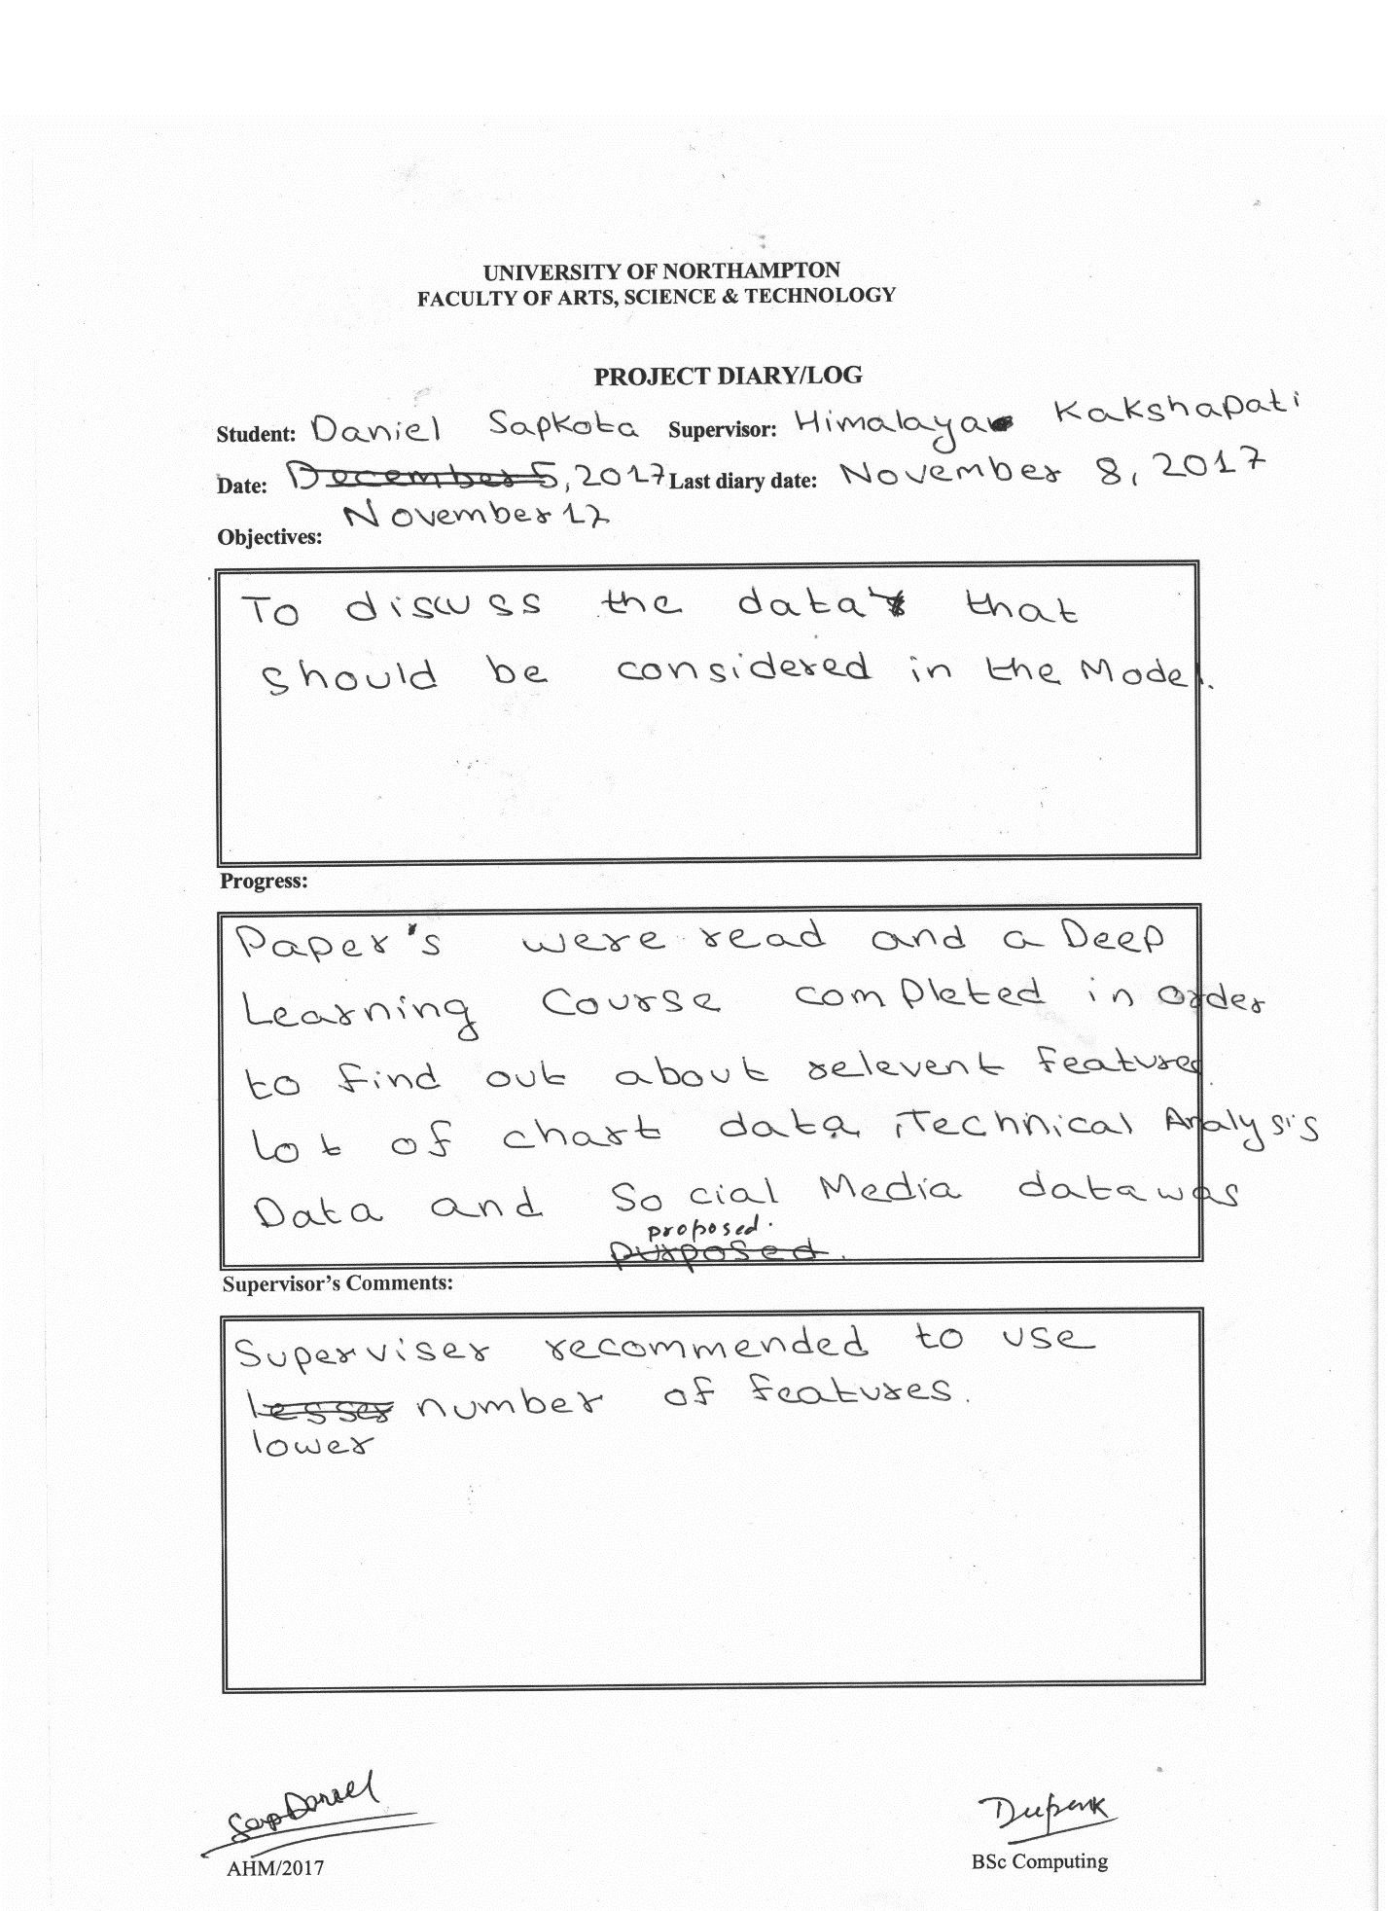

# Appendix 3 – Presentation Slides

|  |  |
| --- | --- |
|  |  |
|  |  |
|  |  |
|  |  |
|  |  |
|  |  |
|  |  |
|  |  |